Thank you for requesting a house contents list, please complete and return to us in the prepaid envelope provided. As we will be quoting from the information you will be providing us items not on the completed list will not be included in the removal.

NAME: | TEL NUMBER:  MOBILE NUMBER:  EMAIL ADDRESS:
MOVING FROM  ADDRESS: | MOVING TO  ADDRESS:
TYPE OF PROPERTY: (I.E. Semi with 3 bedrooms) | TYPE OF PROPERTY: (I.E. Semi with 3 bedrooms)
VEHICLE ACCESS: Our lorries are 36ft (12m) & 13ft (4m) long.  Can they get within 25ft (8m) of your property? Y/N  (Smaller vehicles are available if needed)  Describe access:  (I.E. level with 6 steps) | VEHICLE ACCESS: Our lorries are 36ft (12m) & 13ft (4m) long.  Can they get within 25ft (8m) of the property? Y/N  (Smaller vehicles are available if needed)  Describe access:  (I.E. level with 6 steps)
Please provide your removal date(s) or aimed for date(s): ……………………………………………………………………………………..

Tel: 01271 326200 Email: removals@banburys.com Fax: 01271 327880
LOUNGE: | QUANTITY/SIZE | BEDROOM 1: | QUANTITY/SIZE
3 seat sofa |  | Bed: 6ft/4ft6in/3ft
2 seat sofa |  | Wardrobe: Single/Double/Triple
Arm chairs |  | Chest of Drawers
China cabinet |  | Bedside Cabinet
Bookcase |  | Chair/Stool
Coffee table |  | Desk
Occasional tables |  | Computer
Television & stand |  | Filing Cabinet
DVD player |  | Bookcase
Games Console |  | Pictures/Mirrors
Picture/Mirrors |  | Boxes
Wall unit
Sideboard |  | BEDROOM 2:
Piano: upright/grand |  | Bed: 6ft/4ft6in/3ft
Boxes |  | Wardrobe: Single/Double/triple
 |  | Chest of Drawers
DINING ROOM: |  | Bedside Cabinet
Dining table |  | Chair/Stool
Dining chairs |  | Desk
Wall unit(s) |  | Computer
Pictures/Mirrors |  | Filing Cabinet
Boxes |  | Bookcase
 |  | Pictures/Mirrors
KITCHEN & UTILITY ROOM: |  | Boxes
Kitchen table
Kitchen chairs |  | BEDROOM 3:
Washing machine |  | Bed: 6ft/4ft6in/3ft
Dishwasher |  | Wardrobe: Single/Double/triple
Tumble Dryer |  | Chest of Drawers
Oven |  | Bedside Cabinet
Microwave Oven |  | Chair/Stool
Fridge-freezer |  | Desk
Fridge |  | Computer
Freezer (chest/upright) |  | Filing Cabinet
Welsh Dresser |  | Bookcase
Boxes |  | Pictures/Mirrors
 |  | Boxes
HALL/LANDING:
Table |  | STUDY:
Pictures/Mirrors |  | Computer desk
Grandfather Cloak |  | Computer
Chair/stool |  | Printer
 |  | Filing cabinet
LOFT: |  | Chair/stool
Carpets |  | Shelving unit
Rugs |  | Bookcase
Boxes |  | Boxes
BATHROOM:
Laundry basket
Boxes

GARAGE/SHED: | QUANTITY/SIZE | ANY ITEMS WE HAVE NOT LISTED: | QUANTITY/SIZE
Workbench
Bicycle
Lawn mower
Strimmer
Tools
Timber
Shelving units
Wheel Barrow
Boxes
Ladders
GARDEN:
Table: Glass/Iron/Wood/Plastic
Chairs: Glass/Iron/Wood/Plastic
Sun lounger
Deck chairs
Garden bench
B-B-Q
Swing (dismantled)
Sandpit
Slide (dismantled)
Ride on Toys
Dustbin
Garden ornaments
Garden pots Large
Garden pots Small
Greenhouse (dismantled)
Sectional shed (dismantled)
Wendy/play house (dismantled)
Would you require our staff to pack for you? YES/NO
How many hanging garment containers would you like us to bring (allot 1 carton per wardrobe door):
Total large cartons (as a guide ours are: 44cm x 44cm x 52cm):
Total small cartons (as a guide ours are: 44cm x 44cm x28cm):
Tick any special requirements you may need: | Tick:
Extended liability cover please state amount (you have free liability cover up to £50,000)
Dismantling & re-erecting standard beds & wardrobes
Take down curtains & lampshades
Remove goods from the loft (must have a fitted ladder & fully boarded out)
Storage of your goods

Tips you may find useful on packing and removal.

- If possible finish any laundry well before the removal date to avoid packing damp washing. Keep dirty laundry in a separate bag or box.

- Start your packing early as it always takes longer than you think.

- Start by packing all non-essentials e.g. children’s toys, books and board games that they don’t use regularly. Mark each box clearly with which room they came from.

- Don’t forget the items in your loft; make sure they are all boxed and ready to bring down the day/night before your removal.

- When packing your china and glass use plenty of paper scrunched up between each layer and between each item.

- Try to pack one room at a time, clearly labelling or marking each box as you go, with its contents and which room it belongs to.

- Keep all hazardous materials such as; bleach, paint and aerosol cans in a separate box, clearly marked and kept away from other boxes. Please be aware that we are unable to store these items if you are coming into store. You will need to make other arrangements for storage of these items.

- Think ahead and pack a box for your first night in your new home with coffee/tea, milk, sugar and snacks as well as the kettle and cups. Either take this box with you or make sure it is loaded last, so that it can be the first box off.

CHECK LIST

- When you move house there is a lot to think about and remember. With this in mind we have compiled a guide list of the most common companies & people to inform of your change of address. We hope you find it useful:

- Your work place
- Gas & electricity suppliers
- Water Company
- Council Tax office
- Telephone company/supplier
- Car/home/building insurance companies
- Bank/Building Society/Credit Card Company
- Dentist
- Doctor
- DVLA
- Passport office
- Inland Revenue
- Your children’s school/college if applicable
- Post office; consider having your mail redirected for 3 months.
- T.V: Licence/cable/digital Company
- Milkman
- Newspaper shop
- Window cleaner
- Premium bonds/shares Companies

HOW TO TAPE & PACK YOUR BOXES
- Close the bottom flaps together and tape along the middle edge make sure you overlap onto the sides of the box by about 5”, do a couple of overlapping strips and then run the tape around the bottom edge of the box overlapping the sides and bottom for added strength.

- When packed tape over the top joined edges of the flaps.

- When packing your boxes scrunch up some packing/newspaper to create a cushioned layer at the bottom of your box for fragile goods, wrap your goods well and place onto the scrunched up paper, add scrunched up paper between your wrapped goods. Add another layer of scrunched up paper if you are doing another layer of goods. Just remember that a lot of china will get heavy, try and use smaller items as the second layer. Please allot 1 large carton per kitchen/unit/cupboard door.

- Most people feel happier putting their dinner services into small boxes just remember to use plenty of scrunched up paper and wrap the goods well.

- Please put books only into small boxes due to the weight. Allot 1 small carton per shelf.

- If you can’t fit a picture into a made up box then try this: keep the box flat packed and tape up the bottom, you now have an envelope which you can slide a picture or mirror into now tape up the top, but don’t worry too much as your removal crew will blanket wrap any that don’t fit on the day.

- We will where possible collect your used Banburys boxes after the removal if you have taken us up on the packing service, please flat pack them and ring the office on: 01271 326200 to arrange a collection. Store them in a place that will not inconvenience you as we collect when in the area, sorry but we can’t collect other removal company boxes/supermarket boxes etc as we can’t reuse these and there is a charge to have them collected for recycling.

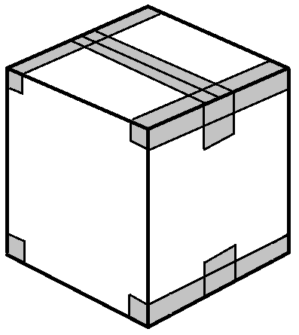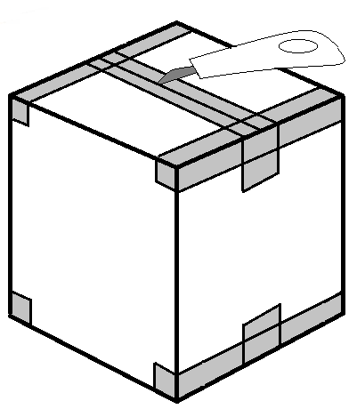

Example: Tape method please cut tape when flat packing

